University Institute of Information Technology
PMAS-Arid Agriculture University, Rawalpindi



Project Proposal
For
Machine Learning Approach to Sentiment Analysis in Telephonic Conversation
Submitted By:
Syed Rafay Ali
- Arid-728
Qasim Mehmood
22-Arid-707
Supervised By:
Sir Hafiz Muhammad Faisal
Submission Date: (12-September-2025)

ABSTRACT

The proposed project aims to develop an AI-powered, multimodal system that inte-
grates Natural Language Processing (NLP) and Speech Emotion Recognition (SER)
to analyze customer-agent telephonic conversations. By combining textual senti-
ment analysis, acoustic emotion recognition, and conversational dynamics modeling,
the system will predict sales conversion probabilities and provide actionable insights
through interactive dashboards. This open-source, cost-effective solution targets call
center managers, sales analysts, and researchers, offering enhanced transparency and
extensibility compared to existing proprietary systems. The project employs Whisper
ASR, DistilBERT/FinBERT, CNN+LSTM, and XGBoost for robust analysis, with a
focus on affordability and explain-ability

ACKNOWLEDGEMENT

We express our gratitude to our supervisor, Dr. Hafiz Muhammad Faisal, for his guidance and support throughout this project. We also thank the University Institute of Information Technology, PMAS-Arid Agriculture University, for providing the resources and environment to conduct this research

Please select the appropriate category of your project (Select multiple if required)
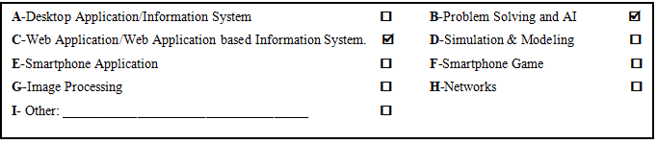
Group Members:
- Student Name: Syed Rafay Ali
Registration No: 22-ARID-728
Class: BSCS
Section: 7C
Shift: Morning
Email: syedrafayali44@gmail.com
WhatsApp No:03198347602

- Student Name: Qasim Mehmood
Registration No: 22-arid-707
Class: BSCS
Section: 7C
Shift: Morning
Email: Qasimmehmood728@gmail.com
WhatsApp No: 03074491228

TABLE OF CONTENTS

1. Introduction 3
2. Objective 3
3. Literature Review 4
4. Problem Statement 4
5. Benchmarks: 5
6. Solution 5
7. Advantages/Benefits of Proposed System 6
8. Scope 6
9. Software Methodology 6
10. Tools and Technologies 6
11. Concepts 7
12. Intended Users 7
13. Mockups 7
14. Timeline 9
15. Conclusion 9
References 9

1. Introduction
Customer-agent interactions in call centers hold valuable insights into customer mood, intent, and buying probability. Traditional sentiment analysis focuses only on binary positive/negative classification, but real conversations involve multi-faceted features such as tone, pitch, speech pauses, conversational context, and emotional dynamics. This project aims to develop an AI-powered, multimodal system that integrates Natural Language Processing (NLP) with Speech Emotion Recognition (SER) to analyze both textual and acoustic data from call recordings. Beyond sentiment detection, the system will estimate conversion probability, track customer-agent dialogue flow, and provide actionable insights through advanced visualization dashboards.

2. Objective
The primary objective is to design a low-cost, open-source, and student-friendly AI system capable of:
Transcribing telephonic conversations using state-of-the-art ASR (Automatic Speech Recognition).
Identifying and classifying customer sentiments and emotional states.
Modeling conversational dynamics (e.g., interruptions, hesitation, sentiment drift).
Predicting the probability of successful sales conversions with interpretable AI techniques.
Providing visual, interactive dashboards for managers to assess customer satisfaction and agent performance.

3. Literature Review
Existing systems fall short of providing a complete multimodal, explainable, and cost-effective solution:
IBM Watson Tone Analyzer – Detects emotions in text but lacks support for prosodic features in speech.
Amazon Contact Lens – Provides speech-to-text and sentiment analysis but is proprietary and expensive.
Google Cloud Speech + Sentiment – Offers transcription and sentiment classification but lacks sales forecasting.

4. Problem Statement
Call centers generate massive amounts of conversational data every day, yet most organizations lack affordable and robust systems that can truly understand not only what customers say but also how they say it. Existing solutions are often restricted to text-based sentiment classification, ignoring important paralinguistic cues such as tone, pitch, stress, pauses, and emotional intensity, all of which carry crucial information about customer intent. Moreover, enterprise-grade tools that provide partial multimodal analysis are often prohibitively expensive, limiting accessibility for academic research and small to medium-sized businesses. Current systems also fall short in capturing the natural dynamics of a conversation, such as interruptions, hesitation, sentiment drift, and agent responsiveness, resulting in incomplete insights. More critically, these tools are largely descriptive and fail to provide predictive analytics, such as estimating the probability of a successful sale, which is a key metric for call centers aiming to optimize operations.

Benchmarks:
Table 1: Comparison of Proposed System with Existing Solutions
Feature | IBM Watson | Amazon Contact Lens | Google Cloud APIs | Proposed System
Text Sentiment | Yes | Yes | Yes | Yes
Audio Emotion | No | Yes | No | Yes
Conversation Flow | No | Partial | No | Yes
Sale Prediction | No | No | No | Yes
Dashboard Insights | Yes | Yes | Limited | Yes
Cost Effective | No | No | No | Yes

6. Solution
Our solution is a multimodal AI system integrating:
Whisper ASR for transcription.
Pyannote.audio for speaker diarization.
DistilBERT/FinBERT for textual sentiment analysis.
CNN+LSTM for acoustic emotion recognition.
XGBoost/LSTM ensemble for sales prediction.

7. Advantages/Benefits of Proposed System
Multimodal analysis (audio + text) for higher accuracy.
Real-time sales conversion probability prediction.
Open-source, cost-effective, and extensible design.
Potential to be integrated into existing CRM systems using Agentic Workflows.
Can be extended for real-time analysis.
Captures hesitation cues (e.g., “ah,” “hmmm,” “ahan”), allowing managers to

8. Scope
The scope includes data ingestion, preprocessing, multimodal feature extraction, model training, predictive analytics, and dashboard deployment. Exclusions include enterprise-scale integration and production-grade real-time streaming systems.

9. Software Methodology
An Agile development methodology will be used with iterative sprints focusing on dataset preprocessing, model experimentation, and incremental dashboard functionality.

10. Tools and Technologies
Table 2: Tools and Technologies
Tools & Technologies | Tools | Version
 | Python | 3.10
 | PyTorch | 2.2
 | Hugging Face Transformers | -
 | Pyannote.audio | -
 | Librosa | -
 | Whisper | -
 | PostgreSQL | 15
 | MongoDB | -
 | React | 18
 | Flask/FastAPI | -

11. Concepts
NLP-based sentiment analysis
Speech emotion recognition (prosody, pitch, MFCCs)
Feature fusion and multimodal deep learning
Explainable AI (XAI) for transparency
Ensemble learning for robust predictions
Human-computer interaction via dashboards

12. Intended Users
Call center managers
Customer support agents
Sales analysts
AI/NLP researchers
Training teams

Mockups

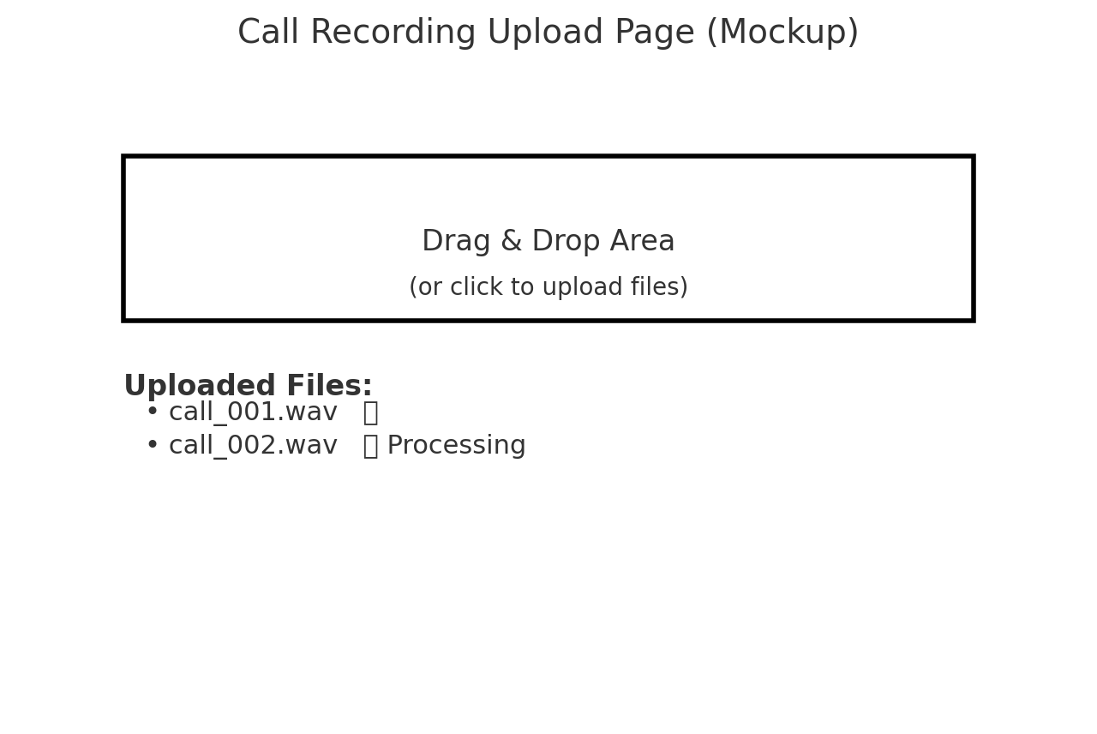

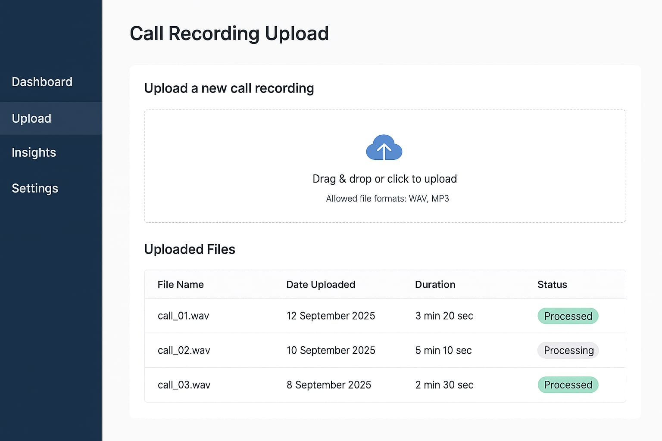

Mockup 13.1: Call Recording Upload Page

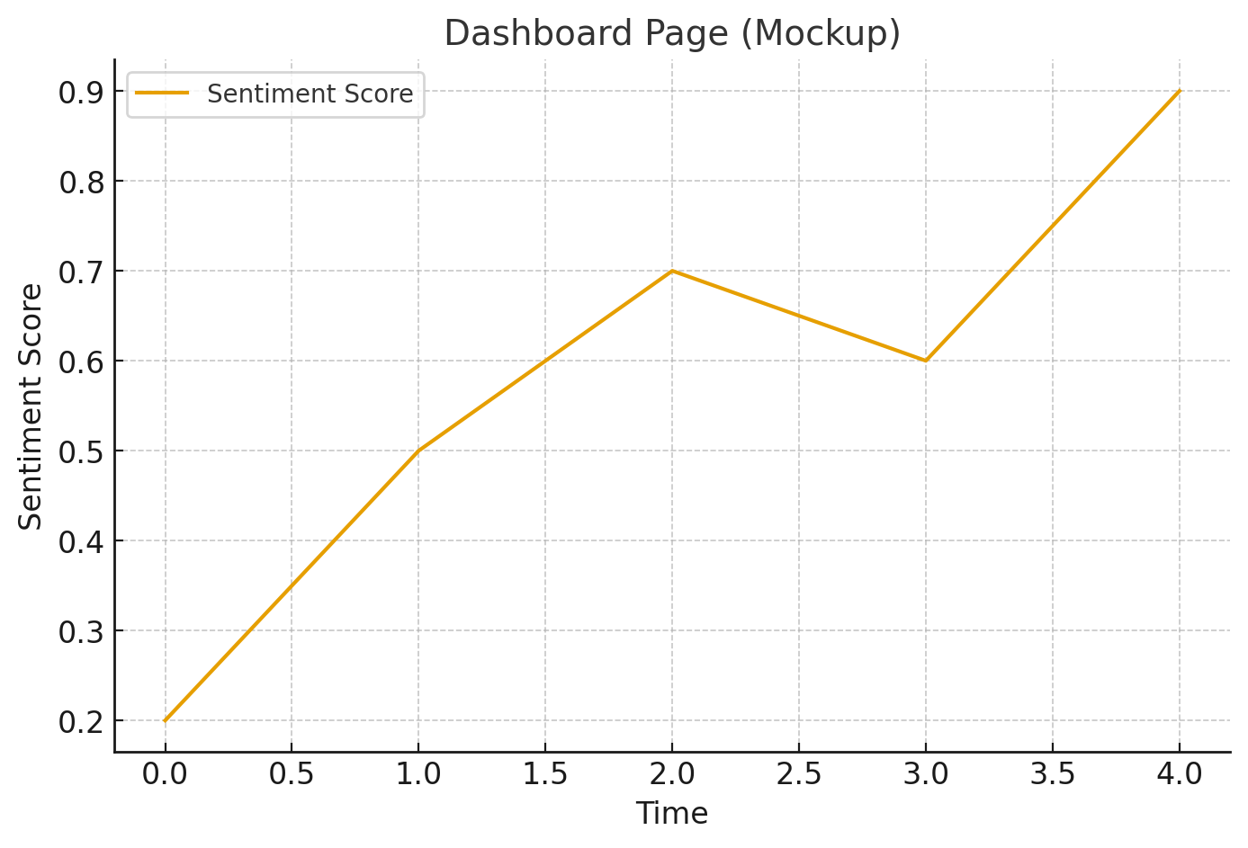

Mockup 13.2: Dashboard Insights Page
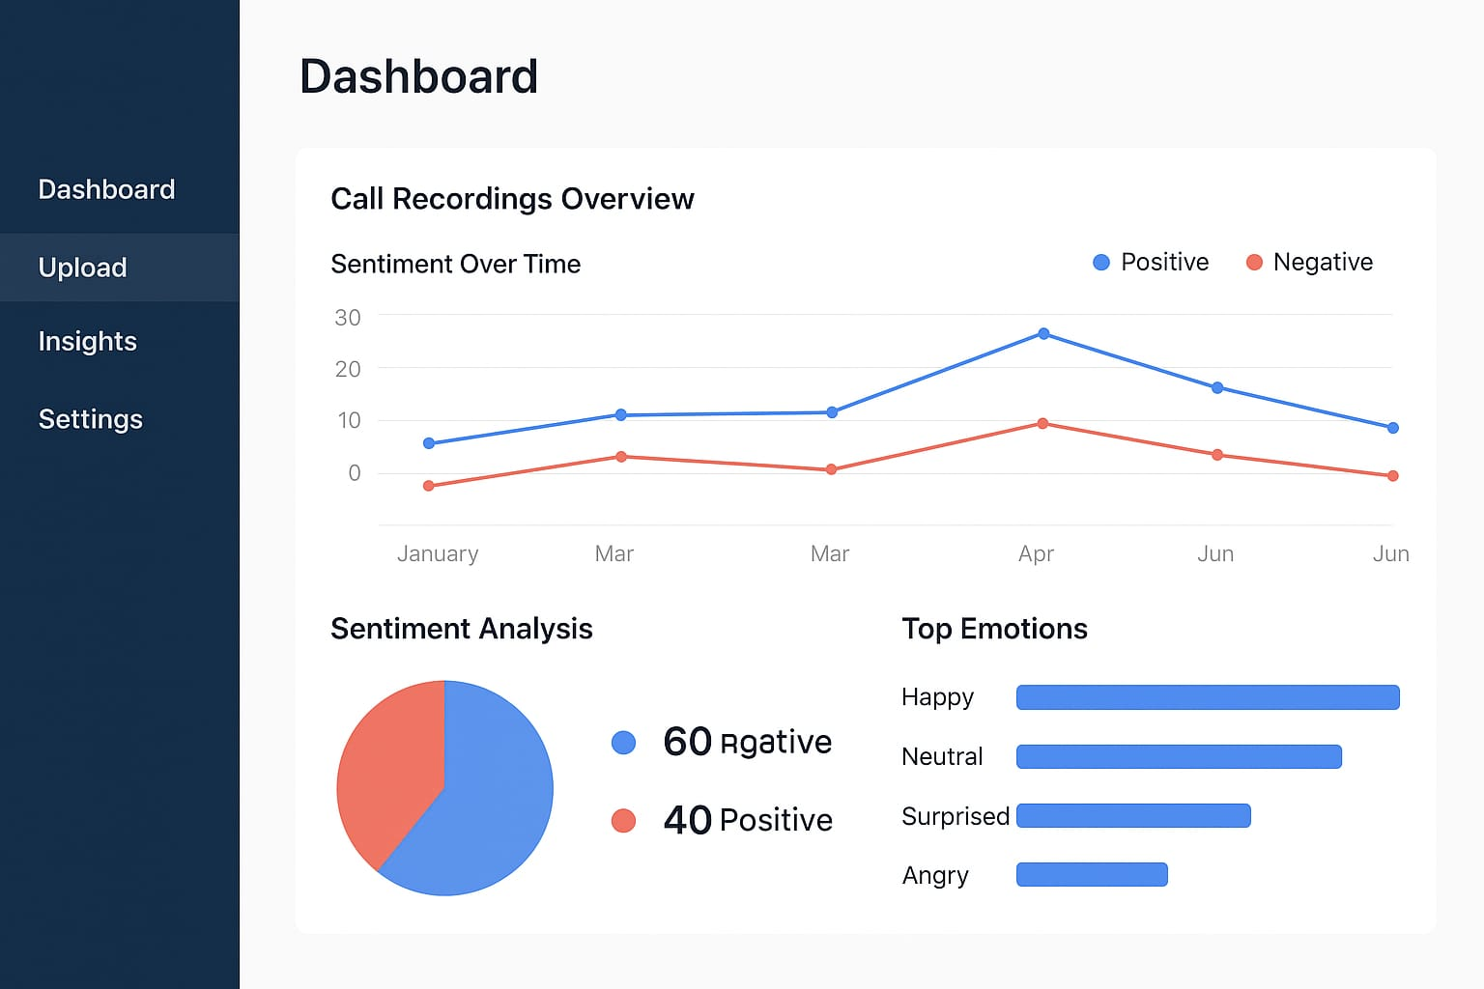

Mockup 13.3: Dashboard Page

14. Timeline
Weeks 1–2: Literature review and dataset collection
Weeks 3–4: Preprocessing
Weeks 5–6: Feature extraction
Weeks 7–8: Model training
Week 9: Dashboard development
Week 10: Integration & testing
Weeks 11–12: Documentation & final report

15. Conclusion
In our work, we aim to design an AI-powered system that not only analyzes customer sentiment from text but also captures emotional cues from speech and conversational dynamics. By integrating Automatic Speech Recognition (ASR), Natural Language Processing (NLP), speech emotion recognition, and predictive modeling, we expect to generate deeper insights into customer intent and sales conversion probability. This dual focus on both multimodal sentiment analysis and predictive forecasting will enhance the practical value of our system, making it suitable for real-world applications in call centers, customer experience management, and sales optimization..

References
IBM, “Watson Tone Analyzer,” [Online]. Available: https://www.ibm.com/watson/services/tone-analyzer/. [Accessed: Sep. 2025].
Amazon Web Services, “Amazon Connect Contact Lens,” [Online]. Available: https://aws.amazon.com/connect/contact-lens/. [Accessed: Sep. 2025].
Google Cloud, “Cloud Speech-to-Text and Natural Language Sentiment Analysis,” [Online]. Available: https://cloud.google.com/. [Accessed: Sep. 2025].
Hugging Face, “Transformers: State-of-the-Art Natural Language Processing,” [Online]. Available: https://huggingface.co/transformers. [Accessed: Sep. 2025].
H. Bredin et al., “pyannote.audio: Neural building blocks for speaker diarization,” [Online]. Available: https://github.com/pyannote/pyannote-audio. [Accessed: Sep. 2025].
OpenAI, “Whisper: Robust Speech Recognition via Large-Scale Weak Supervision,” [Online]. Available: https://github.com/openai/whisper. [Accessed: Sep. 2025].
T. Chen and C. Guestrin, “XGBoost: A Scalable Tree Boosting System,” in Proc. 22nd ACM SIGKDD Int. Conf. Knowledge Discovery and Data Mining (KDD), 2016, pp. 785–794.
B. McFee et al., “librosa: Audio and music signal analysis in Python,” in Proc. 14th Python in Science Conf. (SciPy), 2015, pp. 18–25.

